**Important questions**

**1-mention the types of file formates?**

Audio, video, image, text

**2-mention four of the Video extensions?**

Mov,mp4,avi, wmv

**3-mention four  of the Audio extensions?**

Mp3, wav,aiff, wma

**4-mention four of the image extensions?**

Png, jpg, jpeg, gif

**5-mention four of the text extensions?**

Csv, json, txt, excel.

**6-what's meaning by annotation?**

The task of labeling digital images.

**7-mention the types of annotation?**

Bounding box, polygon, cuboid, key points, text, semantic segmentation, instance segmentation,line annotation.

**8-mention the types of text annotation?**

Name entity recognition(NER),

Part-Of-Speech(POS),

Sentiment Analysis,

Dependency Parsing,

Coreference Resolution,

Text Classification,

Event Extraction.

**9-mention the image characteristics?**

Color system,

pixels,

arrays,

image filtering,

image compression,

image restoration,

edge detection,

image analysis,

image segmentation,

object recognition,

morphological processing.

**10-mention the computer vision fundementals?**

Image processing,

feature extraction,

object recognition and detection,

image classification,

tracking,

scene reconstruction,

machine learning and deep learning,

augment reality.

**11-difference between (wav, Mp3)?**

Wav:-  it's stands for wavform audio file format, and the audio file is uncompressed, the Sound quality of the original audio signals is retained, and It used only in high-quality CDs, professional recording.

Mp3:-  it's stands for MPEG-1 Audio Layer-3,and it's file largely compressed so the Sound quality is heavily decreased, and Mp3 the most common audio format, used for storing and transferring songs.

WMA file extension:- is short for Windows Media Audio, which is an audio file container and serves as an audio codec too. The regular WMA format contains lossy audio data “WMA Lossless” is available too. Widely used for voice content and audio recordings, WMA offers great compatibility with all major multimedia players and editing software.

**12-difference between(coco, yolo, pascal) ?**

Coco:-  coco is a huge image dataset collected for object detection, segmentation, person key points detection, object segmentation, and caption generation, and the annotations are stored using json file. coco x,y top left, w, h.

Method of recording the boundaries of object: polygon-based, speed: slow

Yolo:-  yolo is an abbreviation that stands for you only look once and It useing txt file. yolo x.y center, w, h.

Method of recording the boundaries of object:

Grid-based, speed: very fast

Pascal:- pascal is a data annotation format that stores annotation information in xml format.

pascal: x,y min top left,  x.y max bottom right, Method of recording the boundaries of object:

Rectangle-based, speed: fast.

**13-difference between text extensions?**

1. **CSV (Comma-Separated Values):**

- A text format for organizing data in a table structure.

- Data is separated by commas or specified delimiters (typically comma or semicolon).

- Widely used for data interchange between applications and data analysis.

2. **XLSX (Excel Spreadsheet):**

- A file format for spreadsheets used in spreadsheet programs like Microsoft Excel.

- Organizes cells in rows and columns, supporting text, numbers, images, and charts.

3. **TXT (Plain Text):**

- A simple text format containing plain text without formatting.

- Used for basic data storage, human-readable, and machine-readable.

4. **HTML (Hypertext Markup Language):**

- A markup language used to build web pages.

- Contains encoding elements defining structure, content, and linking between pages.

5. **PDF (Portable Document Format):**

- A file format containing text, images, and graphics independently of software and hardware.

- Used for document exchange across different systems without losing formatting.

6.JSON ( JavaScript Object Notation) : the data is complex, nested, and object-oriented, and you are working with web applications and APIs.

7. XML (Extensible Markup Language) : should be chosen if the data is rich, hierarchical, and document-based, and you are working with XML standards and formats.

**14-difference between image extensions?**

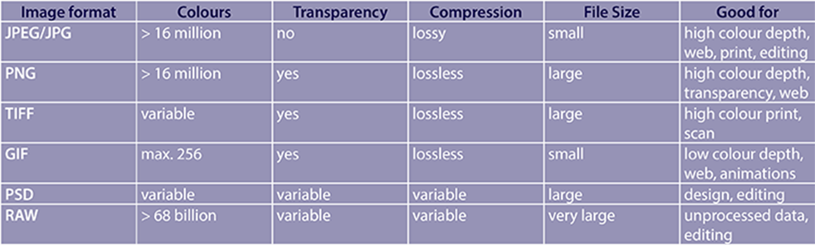

**15-difference between audio extensions?**

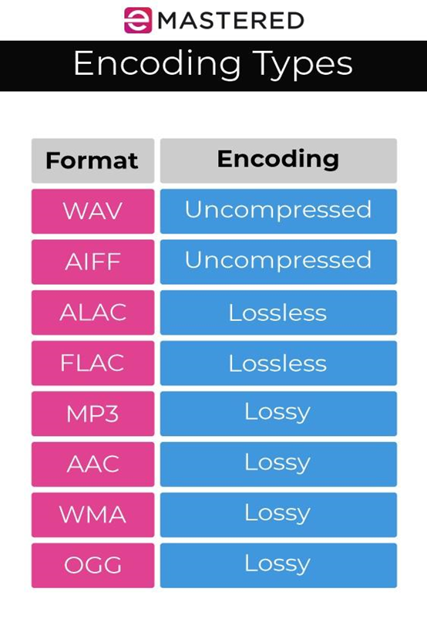

**16-difference between video extensions?**

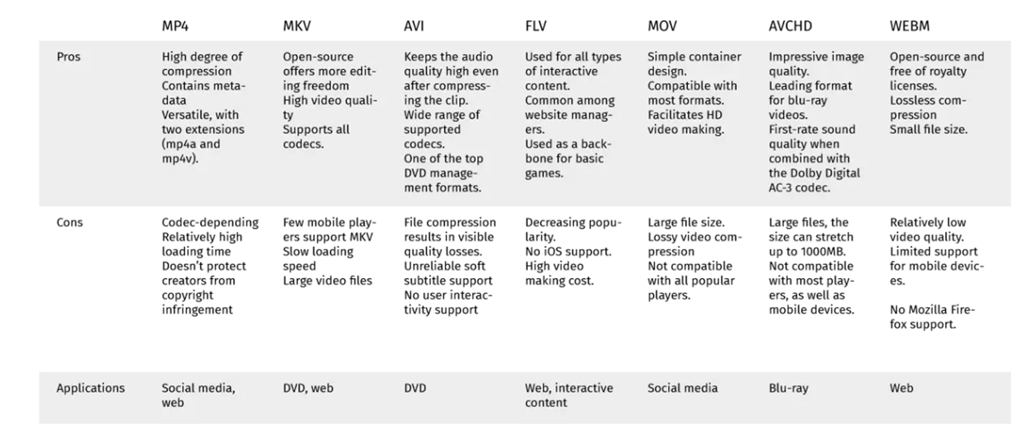

**BY Shahd mostafa**